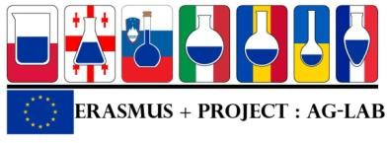

Project “Improving skills in laboratory practice for agrо-food specialists in eastern Europe» (Ag-Lab)
Program Erasmus +, project KA2 n° 586383-EPP-1-2017-1-SI-EPPKA2-CBHE-JP (2017-2978/001-001)

Minute of the training session Tbilisi, 24 – 25 October 2019

Thursday, 24.10.2019

The participants were greeted by Mr. Irakli Guledani,director of the Laboratory of the Ministry of agriculture of Georia. Mr. Guledani highlined the importance of the project and the partnership for the improvement of the laboratory activities.
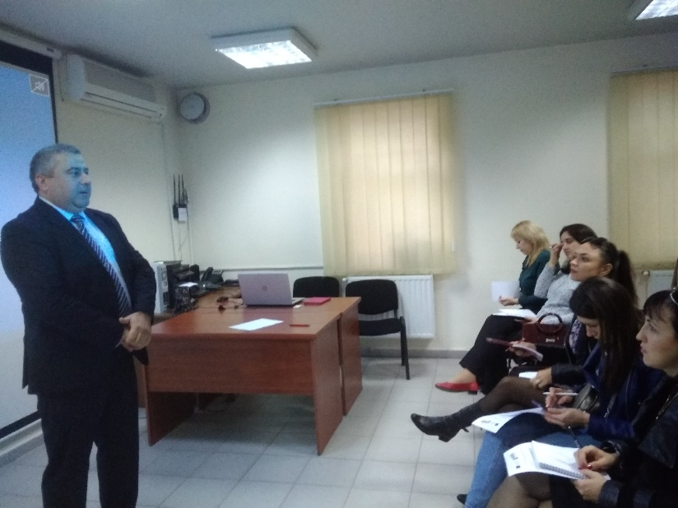

The first presentation done by Mr. Marcello Mascini, professor of the Faculty of Bioscience andTechnology for Food,
Agriculture andEnvironment,University ofTeramo was devoted to the Multivariate statistics: a practical approach for food analysis. On the base of concrete examples Mr. Mascini how to collect and to operate with the results of analyses containing multiples variables and how to operate simultaneously with a big number of samples. The Principal Component Analysis (PCA) was presented and the mode of its application was explained. The presented PCA procedure was followed by some practical exercises that were shown. Then he demonstrated the application of PCA to the Image Analysis and explained its advantages and disadvantages.

(The presentation is available on the link: https://drive.google.com/drive/folders/16DE-YXeVRkXgElngRUppWVO_qkrgXP0Z?usp=sharing)
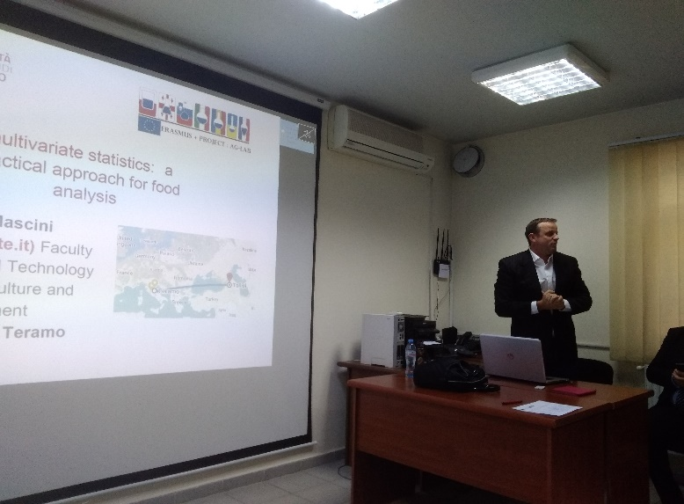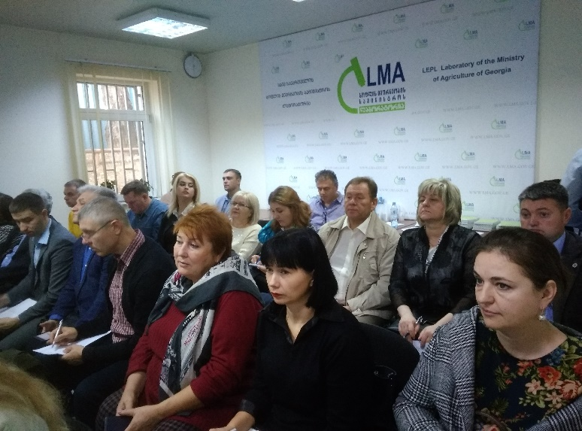

The rest of the day was devoted to the work with the Moodle planform that is being developed within the project. The session was animated by Nikos Palavitsinis, ISLE, Jad Najjar, ISLE and Igor Vereshchagin, SNAU.
After the introduction and explanation of the Moodle capabilities Mr. Nikos Palavitsinis gave the Overview of some of the courses that are already part of the platform and in parallel he demonstrated some slides with general feedback/best practices for creating courses. Mr. Igor Vereshchagin presented the Moodle courses developed by SNAU and explained the mode of their operation.

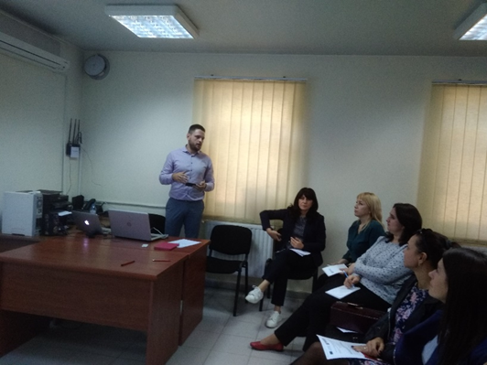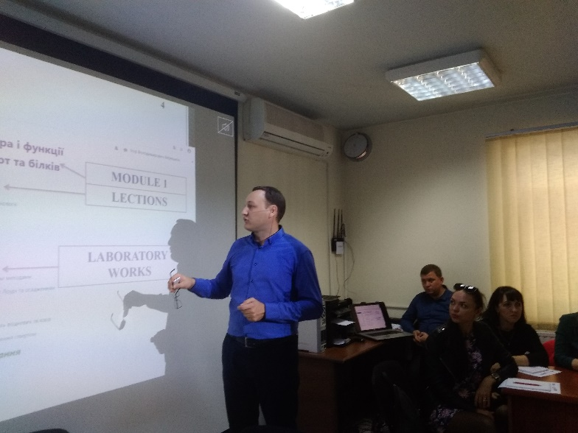

These presentations were followed by the practice session: the Partners worked with Ag-Lab Moodle platform to upload their courses under the surveillance and with the assistance of the experts. The exchange of the partners’ opinions on the Ag-Lab Moodle finished this practical session.

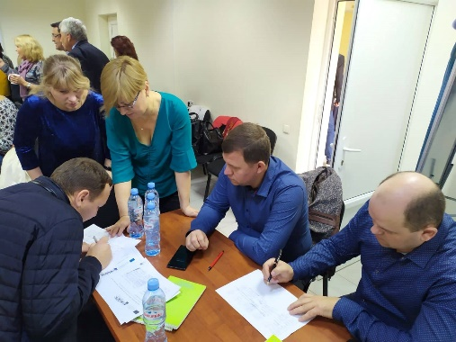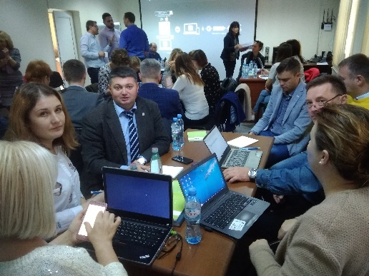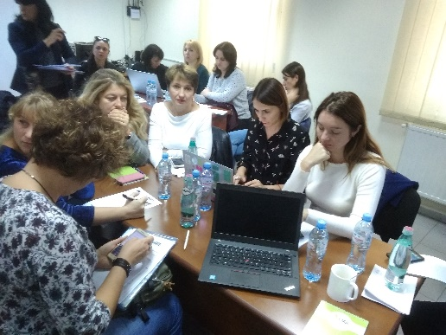

In the end of the day the participants of the training session visited the Laboratory of the Ministry of agriculture of Georgia.
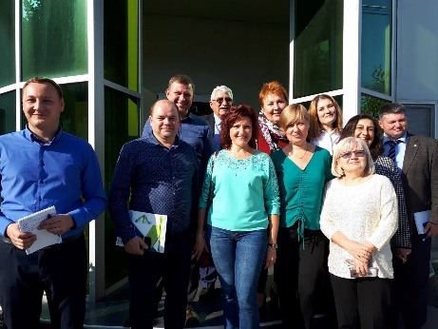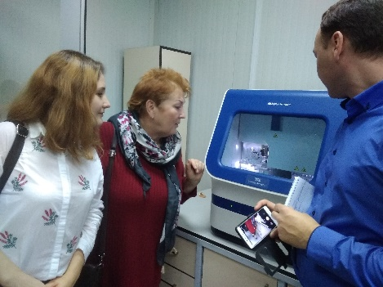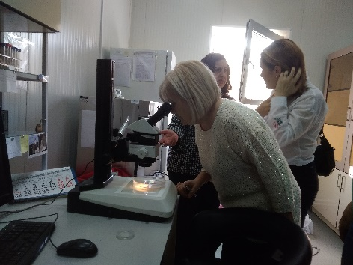

Friday, 25.10.2019

The second day of the training session took place at the Caucasus International University.

After the greeting speech of the rector of the university Prof. Kakhaber Kordzaia and the presentation of the university participation in the Ag-Lab project the participants followed five presentations.

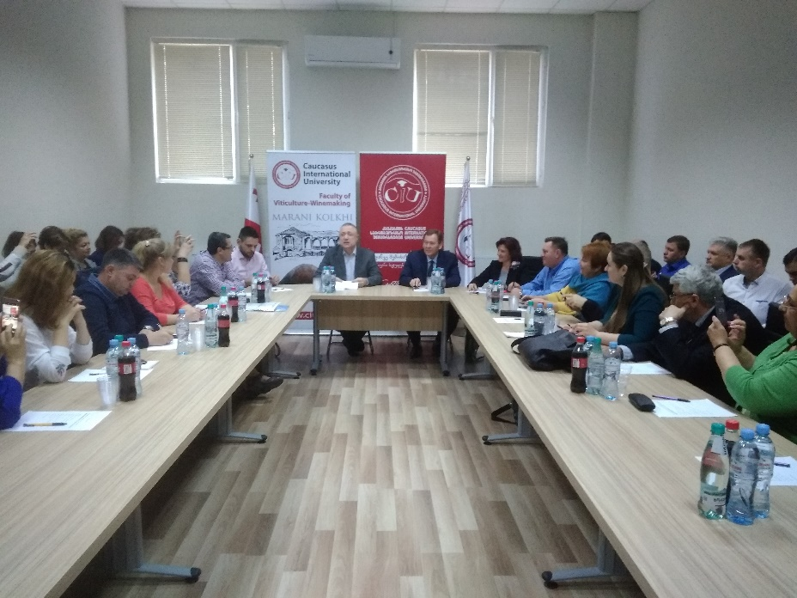

The presentation of Prof. DSc Nidal Shaban and Dr. Eman Kadum from the ISLE Association was devoted to Seeds quality parameters sampling and determination. The sampling procedure of seeds for inspection was explained. Then Mr. Shabam presented different pollutants of seeds, methods of their detection and requirements for seeds quality including minimum tolerable levels of pollution. Other tests such as germination test, growth test, determination of moisture content, determination of mass of seeds were presented as well.
(The presentation is available on the link:https://drive.google.com/drive/folders/16DE-YXeVRkXgElngRUppWVO_qkrgXP0Z?usp=sharing)
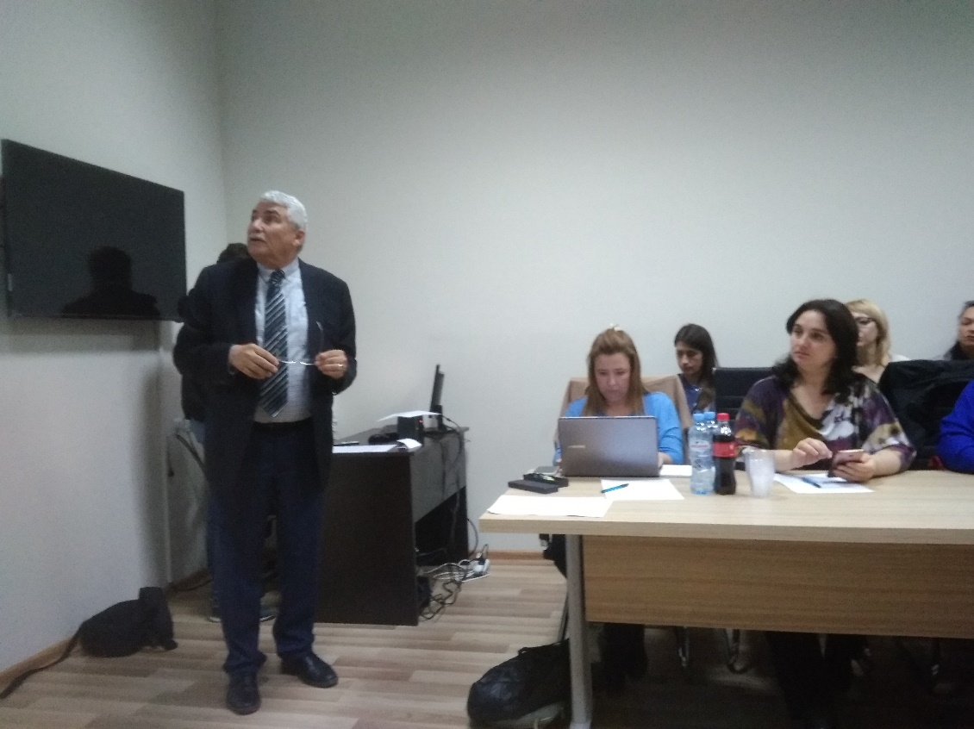

Mrs. Anna Steciwko-Zielak, PhD of the Faculty of Biology and Animal Science of the Wroclaw University of environmental and life sciences made the presentation devoted to the good practice for RNA isolation in transcriptome studies. She explained the notion of transcriprome, presented the main requirements for RNA extraction, handling and storage in order to avoid its destruction by RNAses. The methods and the equipment for the samples preparation were presented as well. The comparative analysis of different methods of RNA isolation was done.
(The presentation is available on the link:https://drive.google.com/drive/folders/16DE-YXeVRkXgElngRUppWVO_qkrgXP0Z?usp=sharing)

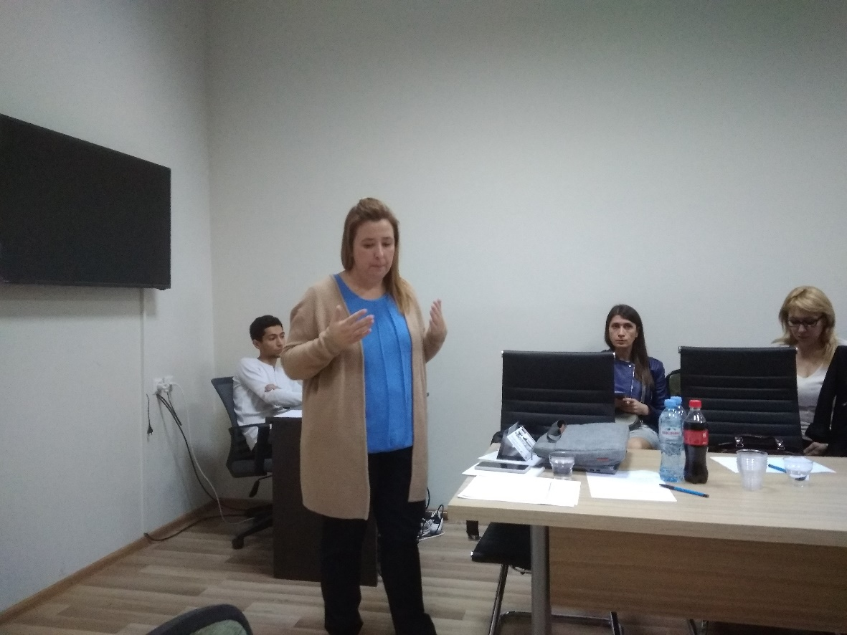

The presentation of Mr. Peter DOVC, professor of the University of Ljubljana, Biotechnical Faculty, Department of Animal Science was devoted to the Application of PCR based methods for food monitoring. In the beginning he compared the PCR method with the Ab detection method. Than Mr. Dovc passed to the PCR method giving its background, variants, PCR based applications, different qPCR formats, Specificity and sensitivity of the method, Advantages of DNA markers, real-time PCR approach. Then Mr. Dovc gave some concrete examples from his own practice of the application of tracing method across foodstuff of animal origin found for monitoring of the Greek market. He finished his presentation by the explanation of the application of PCR methods for GMO detection and its perspectives.
(The presentation is available on the link:https://drive.google.com/drive/folders/16DE-YXeVRkXgElngRUppWVO_qkrgXP0Z?usp=sharing)

The second presentation of Mr. Dovc was devoted to the Molecular approach for traceability of animals and animal products. He explained why the traceability is needed: requirement of consumers, importance in epidemiology, zoonotic aspect and food safety. The IT systems support the traceability. The traceability of animals and animal products can be based on specific genetic traits which are characteristic for a certain breed, population or species. The authentications and traceability systems include information from endogenous and exogenous DNA. DNA barcoding has potential to detect common characteristics of the species. In association with NGS strategies the power of he method can be tested on very complex materials (environmental samples)
(The presentation is available on the link:https://drive.google.com/drive/folders/16DE-YXeVRkXgElngRUppWVO_qkrgXP0Z?usp=sharing)

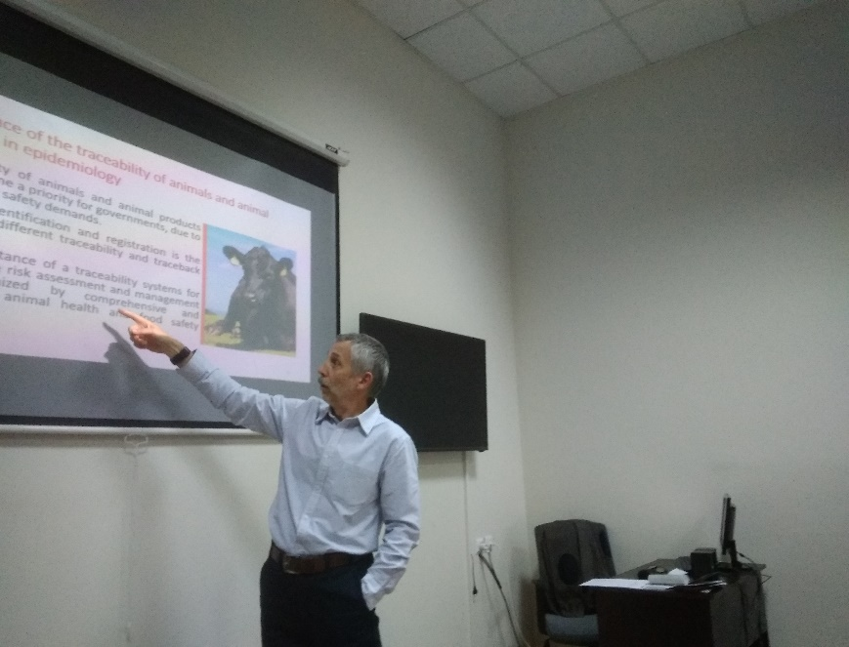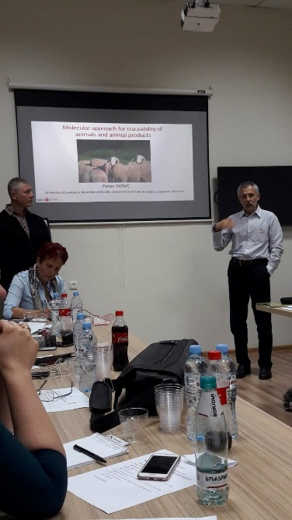

The presentation of Mr. Robert Gerard, head of the metrology service of VetAgroSup Lyon (via Skype) was devoted to the traceability in laboratory practice, paper and digital traceability, their advantages and disadvantages. Then he spoke about the uncertainty of results, control during and after analysis, reporting of analyses results. (The presentation is available on the link:https://drive.google.com/drive/folders/16DE-YXeVRkXgElngRUppWVO_qkrgXP0Z?usp=sharing)

In the end of the training session the participants visited the wine laboratory of the university equipped in the framework of the project.

